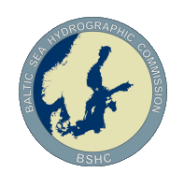
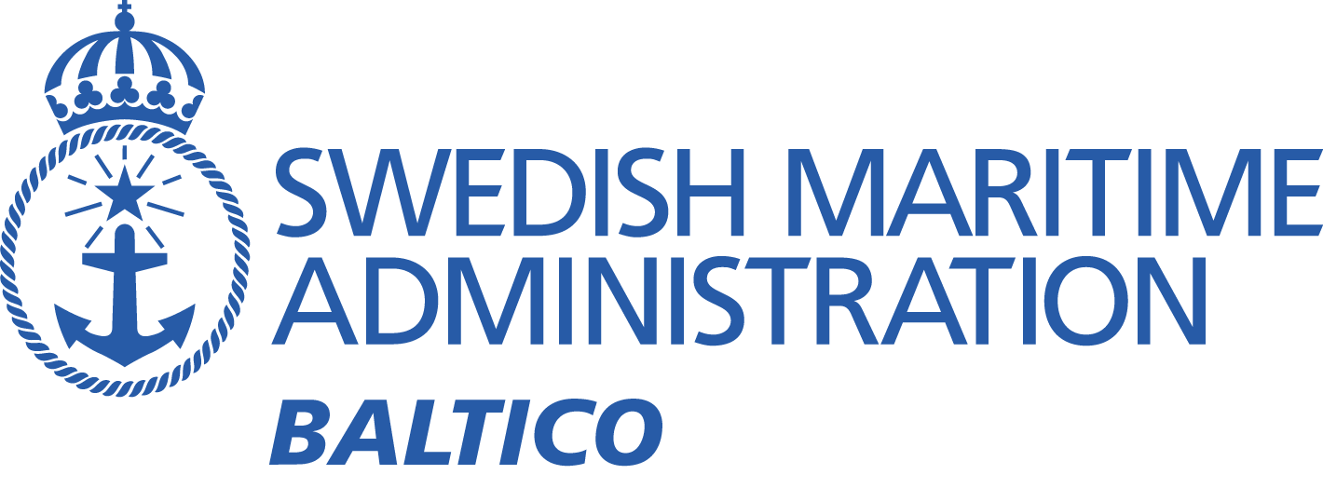

Baltic Sea MSI Working Group On-line Meeting – 27th November ‘20

Meeting minutes
Participants:
Canada Eivind Mong (EM)
Denmark Ulla Bjørndal Møller (UBM)
Estonia Olavi Heinlo (OH)
Estonia Darja Jokk
Estonia Jüri Grigorjev (JG)
Estonia Aleksandr Laur
Estonia Christjan Kaasik
Estonia Taimi Paljak
Finland Marja Aarnio (MA)
Finland Janne Virtanen (JV)
Germany Wilfried Behncke (WB)
Germany Carola Heitmann-Bacza
Germany Henning Sauer
Germany Elena Maria Gnehm
Germany Thies Schlunzen
Latvia Bruno Spels
Latvia Aigars Gailis
Lithuania Emilis Tertelis (ET)
Lithuania Mindaugas Zakarauskas
Sweden Johan von Bültzingslöwen (Chair)
Sweden Michel Rönsen
Sweden Sandra Fyrstedt
Sweden Thomas Gränne
UK Murdo MacDonald (Meeting Secretary)
UK Neil Salter (IMO Navtex Co-ordinating Panel)
UK Christopher Gill (IMO Navtex Co-ordinating Panel)
Apologies:
Poland Dariusz Grabiec
Poland Dariusz Tomczak
Norway Trond Ski (Vice Chair, WWNWS-SC & Navarea XIX Co-ordinator)
Russian Federation

Introduction
The meeting was conducted using Skype and commenced at 13:00 UTC (15:00 CET) with an introduction from the Chair, who reminded members where BSMSIWG information is held online, requesting that members check their details are up to date on the website, and contact the Chair to request updates if required.

Recap of BSMSI1 Meeting Action Points (May 2020)
1 | Invitation to Mr Eivind Mong to the next meeting for an update on the progress of the S-124 | Before next meeting | Chair | Complete
2 | Power of Tallinn Navtex transmitter? | Investigate | Chair/ Estonia | Ongoing – nothing to report
3 | Interference problems Gislövshammar/Varna with same B1 character. Reduction of Varna transmitting power at night? Other solutions? | Investigations and testing | IMO Navtex coordinating panel/ Lithuania | Ongoing - Discussion below under 4.1
4 | Automatic monitoring system of Navtex reception? | Investigations | Chair/ SMA | Ongoing – nothing to report
5 | Areas and borders (Met/ Nav warning areas does not match) | Keeping the issue alive | Estonia/ Finland/ UK/ Chair | Ongoing – *)
6 | Presentation of statistics and examples of overload for the Gislövshammar transmitter to IMO Navtex coordinating panel | As soon as possible | Swedentraffic | Complete
7 | Finding the best way to even out the workload of the Navtex transmitters | Investigations | Chair/ SMA/ IMO coordinating panel | Ongoing – Discussion below under 4.2
8 | Suitable replacement for on-line meeting service. Skype not preferable. | Before next meeting | Chair/ All | Complete - Chair not allowed to use other service for meetings.

*) Chair noted that this is also an action for BSICCWG. OH (Estonia) requested that the issue not be forgotten. MA (Finland) gave update on progress of discussions with Nick Aston, METAREA I Co-ordinator. Discussions ongoing, possible report on progress at next meeting.
- S124-PT progress, report by Eivind Mong, Chair of project team
EM gave a briefing on the work of the S-124 PT, explaining the background to the project, and his role in leading the project. EM discussed S-124-PT’s engagement and cooperation with other bodies, S-124 portrayal and development, progress in light of COVID-19, and candidate solutions for distribution of S-124 Navigational Warnings to vessels. (Link to S-124 Project team)
Chair noted the potential impacts for MSI providers considering new methods for distributing Navigational Warnings. EM gave some insight into the distribution system currently used for disseminating MSI in Canada, discussed the benefits and noted that the system is based on the Danish Njord system. Other questions as follows:
Q. OH – Does the lock symbol in slide (10) represent encryption?
A. EM- Digital signature to authenticate origin of data.
Q. MM – Will you be able to see all nav warnings within a specific area; such as a Navarea?
A. EM- Yes there will be a non-intrusive way of seeing a list. Such as new data etc. It’s unlikely to be by Navarea but more based on route.
Q. ET - How is it info dissemination done between local and regional ones in your system?
A EM-in the Canadian system there is no difference in the way reginal and local MSI is disseminated.
Discussion on changes in procedures from MSI producers.
Q. ET - What are the error rates in your tests?
A. EM- Not known.
Q. JV- What is the estimated timescale for S-124 to be available?
A. EM - Was supposed to be this year, but a draft V1 is expected mid next year before WWNWS13. Then 18 – 24 months for testing. The V2 for operational testing. 2026 for S100 ECDIS.
Q. ET – Will test data sets be made before an operational version comes into being?
A. EM- Yes, before Version 1.

Navtex issues

Interference Gislövshammar/Varna
Recap of the issue: Interference in Baltic Sea area, especially near Baltic States, affecting ability of vessels to receive Gislövshammar Navtex at night. Navtex from Varna, Bulgaria being received instead due to the effects of radio propagation. Varna station reports already reducing power at night and also reports similar disturbances from the Gislövshammar station.
JG (Estonia) recalled a similar problem with the Tallinn transmitter, and suggested a B1 character change may be needed for Gislövshammar to solve this issue, as extensive tests was conducted for the Tallinn transmitter, and the change of B1 character was found to be the only solution.
Navtex chair pointed out limited slots are available so this would not be an easy solution. Changing the B1 character could also limit the function of borrowing time from other transmitters around the Baltic.
More discussion in smaller group required to find a suitable way forward. Navtex chair thanked JG for Tallin Navtex data and requested inclusion of data in meeting minutes if possible.

4.2 Gislövshammar workload
Discussion on high traffic from Gislövshammar. The number of messages is increasing continually. Swedentraffic is reliant on ‘time-slot borrowing’ functionality to broadcast effectively.
Discussion on how to address the issue, Chair pointing to moving planned activities from Navigational Warnings to Notices to Mariners when possible.
Chair asked for communication assistance for the possibility to create chart information in some areas that has many warnings of military exercises. Navtex chair agreed to help investigate with relevant National Co-ordinators. Chair mentioned the alternative possibility of amending Grimeton Navtex service area to help address the problem but noted disadvantages of this solution.

COVID-19 issue update
Discussion on maintenance of service during the COVID-19 pandemic. No issues was reported from any country. Chair requested members maintain contact and request help if required.

Information about current and coming major operations and changes in the Baltic Sea Region
6.1 Chair and UBM (Denmark) reported on successful TSS implementation in Kattegat. No incidents has been reported as a consequence of the introduction of the new TSS.
6.2 WB (Germany) reported the ongoing development of a tunnel between Lolland and Denmark. UBM (Denmark) also provided some background information and confirmed that mariners are being kept aware of developments and that cooperative German/Danish VTS will be in operation. To receive weekly information with complete collection of last weeks MSI, you can subscribe. (Link)
6.3 WB (Germany) noted a changed Navtex receiver position from Emden to Norderney. Good reception at the new site.

Meeting conclusion
Chair thanked the members and noted that it is too soon to make plans for a face to face meeting. Meetings will continue to be via video conference with the next meeting in May 2021. Skype will be used until further notice.

Action point list
1 | Power of Tallinn Navtex transmitter? | Investigate | Chair/ Estonia
2 | Interference problem Gislövshammar/Varna with same B1 character. | Discussions in smaller group to find best solution | IMO Navtex coordinating panel/ Lithuania/Estonia
3 | Automatic monitoring system of Navtex reception? | Investigations | Chair/ SMA
4 | Areas and borders (Met/ Nav warning areas does not match). | Discussion with Nick Ashton (UK) | Estonia/ Finland/ UK/ Chair
5 | Uneven workload of the Navtex transmitters | Discussion on chart amendments and other means to solve issue | Navtex coordinating panel/ National coordinators

Attachments and useful links
- Presentation S-124PT by Eivind Mong
- Tallin Navtex data
- Link to online presentation of Navtex reception from Norderney (Germany) (https://www.dwd.de/DE/fachnutzer/schifffahrt/funkausstrahlung/navtex/_node.html )
- Link to the Femernbelt Tunnel Project (Denmark)
(https://femern.com/en/Tunnel)

Take care. Hope you have a good 2021.
Best regards,
/Johan von Bültzingslöwen

