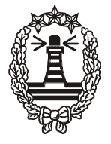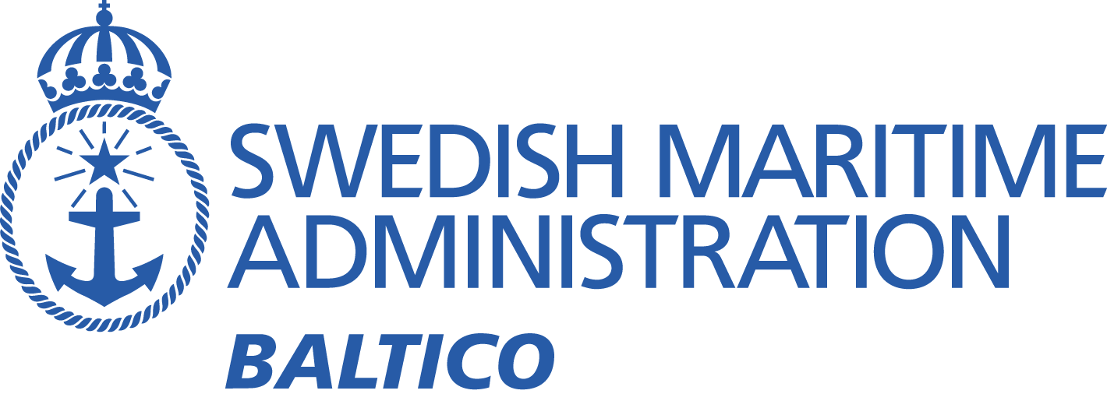

**BALTICO MEETING 2018**

**Saint Petersburg 24-25 April 2018**

**Summary Report**

1. Opening of the meeting

The Russians hosts opened the meeting.

2. Election of chairman

Malin Liljenborg from the Swedish Maritime Administration was elected for chairman. Agneta Hedström was elected secretary.

3. Meeting arrangements

The chairman guided us through the schedule for the two days.

4. Adoption of the agenda

The proposed agenda, as posted on the Internet, was adopted with no additions.

5. Introduction of participants

The participants introduced themselves.  
A list of participants is in Annex 2 and on the Baltico website:  
<http://fyren.sjofartsverket.se/pages/24800/Baltico%20Meeting%202018/2018%20List%20of%20Participants.pdf>

6. Review of actions from the Tallinn meeting 2016

Svante Håkansson (Sweden) presented the list (see below) of actions items from the previous meeting.

|  |  |  |  |  |  |  |  |  |  |  |  |  |  |  |  |  |  |  |  |  |  |  |  |  |  |  |  |  |  |  |  |  |  |  |  |  |  |  |  |  |  |  |  |  |  |  |  |  |  |  |  |  |  |  |  |  |  |  |  |  |  |  |  |  |  |  |  |  |  |  |
| --- | --- | --- | --- | --- | --- | --- | --- | --- | --- | --- | --- | --- | --- | --- | --- | --- | --- | --- | --- | --- | --- | --- | --- | --- | --- | --- | --- | --- | --- | --- | --- | --- | --- | --- | --- | --- | --- | --- | --- | --- | --- | --- | --- | --- | --- | --- | --- | --- | --- | --- | --- | --- | --- | --- | --- | --- | --- | --- | --- | --- | --- | --- | --- | --- | --- | --- | --- | --- | --- | --- |
| |  |  |  |  |  | | --- | --- | --- | --- | --- | | **Agenda item** | **Description** | **Action by** | **Finished by** | **Notes** | | **9** | Consider to participate in tests within EffienSea2 (coming S-124 standard | All interested | Middle of 2017 | For more info contact Mads Berentzen Billesö mcb@dma.dk | | **11** | Include Weather warnings on the Baltico-web page | SMA | Next meeting |  | | **12** | Monitor Tallin Navtex reception by means of the Navtex monitoring station in Hoburg Gotland | SMA/Estonia | As soon as possible |  | | **12** | Examine the possibility of establishing an automatic system for monitoring the reception quality of Navtex | SMA | As soon as possible |  | | **12** | Investigate problem with Mondolfo | Navtex Co Panel | As soon as possible |  | | **13** | Ask WMO to adapt the new names and borders in the Baltic Sea area | SMHI/FMI | As soon as possible |  | | **13** | Investigate how and when each country can adopt the new names and borders and apply it to MSI | All | Before next meeting |  | | **16** | Consider changes to the chart information about reporting during wintertime in the Sea of Aland | SMA/FTA | As soon as possible |  | | **16** | Should a note be included in nautical charts with information about that the TSS in Northern Quark could be withdrawn during winter | SMA/FTA | As soon as possible |  | | **17** | See if it is possible to apply for EU grants for the developing of a common automatic NAVTEX monitoring system for the Baltic Sea region | SMA |  |  | | **20** | Add information to the contact list regarding Denmark | SMA | As soon as possible |  | | **24** | Investigate in how DSC is used for MSI messages | All | Before next meeting |  | | **26** | Next meeting, place and time | SMA | Before 31 December 2018 |  | |

The items were commented as follows:

**No 9.** There was no need to participate in the tests.

**No 11.** Include weather warnings to the website Baltico is done.

**No 12.** Monitoring navtex Hoburgen Gotland is done. Will come back with the result.

**No 12.** Examine the possibility of establishing an automatic system for monitoring the reception quality of Navtex. Have not been done.

**No 12.** Problem with Mondolfo, further discussion on this meeting.

**No 13.** Name of the Sea Areas will be discussed during the meeting.

**No 16.** Reporting Sea of Aland during winter time is done.

**No 16.** The information about TSS in Northern Qark could be withdrawn during winter is included in NTM but not in the Chart.

**No 20:** Add information to the contact list regarding Denmark is done.

**No 24:** This point will be discussed during the meeting.

7. Presentation of national reports

Each country presented their national reports with focus on the changes since previous meeting. All reports are available on the website [www.sjofartsverket.se/balticomeeting](http://www.sjofartsverket.se/balticomeeting).

*Following brief notes were taken during the presentations:*

Denmark

For now they do not know who will be the next coordinator.

Sweden:  
Malin Liljenborg will take over Svante Håkanssons roll as a coordinator. Svante showed statistics over sent navigational warnings during 2017. Tallin right now (U) will be (F) probably from the 1 july 2018.

8. S-124 (MSI in ECDIS)

Malin Liljenborg informed that this is now out for remiss. Comments will be sent latest 30/4 2018. The proposition is that T and P notices will be included in the S-124 standard. Malin pointed out that this project is important to include the information in ECDIS.

9. Efficiensea2

Malin Liljenborg presented the project.

The project has involved a total of 32 European partners and has developed solutions such as the Maritime Connectivity Platform in order to create a more

secure and seamless data exchange in the maritime world.

The feature that all EfficienSea2 solutions share, , is that work on them will be continued and will continue in other projects.

10. Implementation of new Chart Datum (BSCD2000)

Finland

BSCD2000 will start in 2020 in nautical charts. ENC will be published regional based starting point Bay of Bothnia. Expected period 6-8 years. Cooperation with stakeholders is ongoing.

Latvia

Report on the website.

Sweden

For now it is implemented in northern Sweden both ENC and paper chart

Estonia

Started July 2017. Planning to publicate during 2018 in NTM and in seachart. Link on the website. [www.vta.ee/?lang=en](http://www.vta.ee/?lang=en). There is god information on the website, explains Why? How? and When? <http://on-line.msi.ttu.ee/meretase> Will take up to seven years, no changes for Inland waters.

Russia

Russia more doubtful how it will be for the navigators. Not approved by Baltis Sea Hydrographic committee meaning not official. Will take it slowly.

German

Will not be influenced.

Poland

Waiting for decision.

11. Ammended Plane of Reference for information of warnings concerning extreme Sea Level in Sweden and other nations

Lisa Lind informed that they started the project to adjust to the new referencelevel RH2000.

12. Current and coming major operations and changes at sea int the Baltic Sea Region

Finland

NordStream 2 gaspipeline south Helsinki from augusti-september 2018. Data cable between Finland and Estonia summer 2018, timetable for the work is unknown.

Sweden

The Luleå project will be in progress 3 years. Will make the fairway in to Luelå deeper.

13. Method and procedure for sending MSI to Baltico

No one had anything to discuss. It is works well.

14. Disturbances to NAVTEX broadcasts

Estonia Navtex has been relayed via Suurupi transmission station. Estonia have problems with Mondolfo which have a stronger signal. Alexander presented the measuring that has taken place regarding interference by Mondolfo which is 1500 km away from Tallinn Radio. To maximate the strength it will be a renew ground system. New Navtex IP-based transmitter 1000 W output.

15. Change of transmission times and area ID character for the Tallin NAVTEX station

16. Names of Water areas in the Baltic Sea (General area, Locality)

Discussion were taken place and each country got to say there meanings

Finland

Make a note to this report and make an actions for Baltico meeting

Sweden

Svante think we must go back to Baltico Hydrographic and ask for a clarification why they have decided changes of names in the areas in the Baltic Sea. The decision from 2014 is withdrawn.

No other country have nothing more to say about the issue. Sweden will take the issue back home and discuss further.

17. Information about the work in WWNWS-SC, IMO NAVTEX

Bill Navarea 1 Coordinator from UK informed about the work.

18. IHO S-53 and the NAVTEX manual

IHO have free document, IMO charge for their documents. All member states can participate or use their subcoordinator to bring upp different items and issues.

**19. Meteorogical Warnings and Forecast**

Everything working well. Bill remind of the meeting in Monaco in august for the Metcoordinator.

20. Routines regarding MSI during winter conditions

Finland

Beginning of the winter a general warning winter effect via VHF and Navtex. Spring a general warning regarding unreliable AoNs after winter, VHF and individual warnings for critical AoNs faults via Turku Radio. All warnings are posted on the website

Latvia

December general warning, spring general warning about unreliable SSA. Ice info via harbour master.

Sweden

Similar like Latvia and Finland

21. Monitoring of NAVTEX broadcast

Svante Håkansson informed how important it is to monitor that navtex are broadcasted. Finland do not have that routine to monitoring navtex. Svante asked them to look over the routine. Latvia have the routine to monitor. Bill pointed out if you transmit Navtex you must monitor so the warnings will be sent.

22. Relationship between NtM and MSI

Svante asked how long time before UK have it in NtM. Bill respond that according to Solas Boradcast and NtM are compelling. You should send the message as long as they are valid, not more than six weeks.

Denmark have three weeks instead of six weeks. Russia warning in force more than six weeks goes to NtM. The decision is taken by another department in Kaliningrad. Denmark said it is important for the future need of E-nav that not both nav.warning and NtM are at the same time, otherwise it will be double.

23. MSI on internet, mobile phone, APP etc

Estonia showed at the last meeting in Tallin a testversion and now it is up and running.

24. The use of virtual AIS

Denmark are using, they were early to start with virtual AIS

Sweden are going to get access to 10 MMMSI number to use for Virtual AIS. Finland have 2000 MMMSI number to use for bouys, Finland use them a lot.

25. The use of DSC.

Svante describe the routines concerning the use of DSC for MSI. Finland use DSC in case of more severe gailwarning and new navigational warning between routine broadcasts. Svante informed that Sweden will look over this with use of DSC.

Denmark use DSC within their area.

26. Terms of reference for Baltico Meeting

Svante started with a short history how these meetings began. These meetings have been successful. Discussion how we should continue. Keep the meetings as today, workinggroup under Baltico Hydrographic committee.

Poland

Idea is good will come back with a formal answer latest 10 May 2018

Latvia

Neutral

Finland

Support workinggroup under Baltico Hydrographic committee

Denmark

Leaving answer via e-mail.

Estonia

Leaving answer via e-mail

Russia

Subject for further discussion

Svante will take answers and opinions via e-mail before 10 mai 2018. After that we will take a decision how we move forward.

27. Any other Business

Text to Speech, finland have not found any “robot voice” which can translate to Finnish. Sweden will look at this in autumn 2018.

28. Next Meeting

Next meeting in Finland april 2020

29. Review of actions

The Action List was reviewed, see annex 1

30. Closure of meeting

This meeting was Svante Håkansson last meeting and Malin Liljenborg thanked Svante for his work with this group with flower and presents. Svante Håkansson thanked all participates for all years with god work and closed the meeting.

**Annex 1**

**List of actions**

|  |  |  |  |
| --- | --- | --- | --- |
| **Agenda item** | **Description** | **Action by** | **Finished by** |
| 16 | Names of water areas in the Baltic Sea. Answer back to Finland | All |  |
| 26 | Terms of reference for Baltico Meeting. Anser back to Svante Håkansson | All | 10 May 2018 |